Load the R0 register of Bank0 with an immediate operand <<D1>>. Load the register R1 of Bank0 with an immediate operand, <<D2>>. Exchange the contents of Registers R0 and R1. Verify the contents of both the registers before and after the exchange.

**PROGRAM**

mov R0,#3h

mov R1,#10h

mov A,R0

XCH A,R1

mov R0,A

END

**OUTPUT**

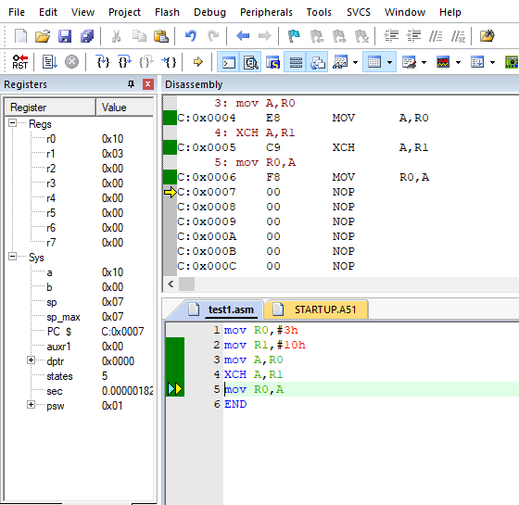

1. **Store the data <<D3>> and <<D4>> directly into the Internal RAM addresses 20h and 30h respectively. Transfer (using direct addressing mode) <<D3>> from 20h into the register R2. Transfer (using Indirect addressing mode) <<D4>> from 30h into register R3.Then store the contents of registers R2 and R3 into 30h and 20h respectively.**

**Program**

mov R0,#20h

mov R1,#30h

mov @ R0,#3h

mov @ R1,#10h

mov R2,20h

mov A,@ R1

mov R3,A

mov A,R2

mov @ R1,A

mov A,R3

mov @ R0,A

End

**Output**

**Before**

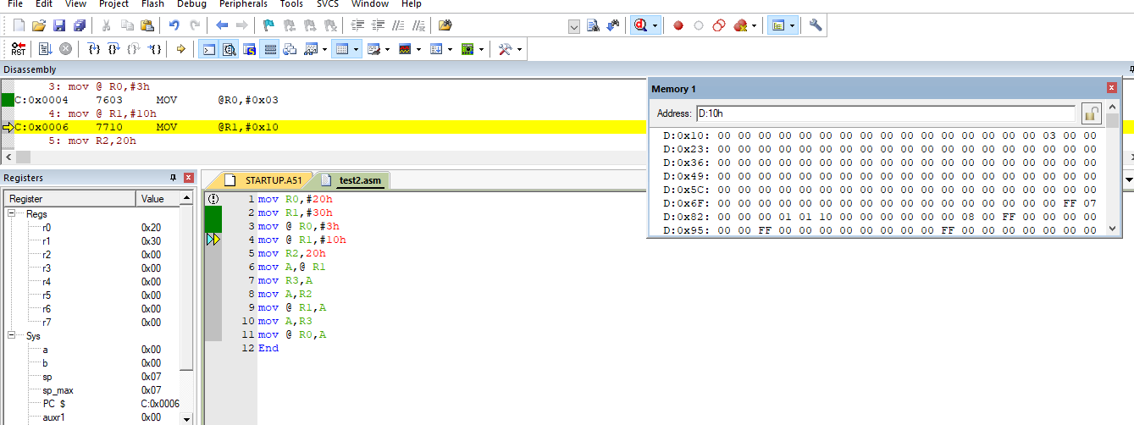

**After**

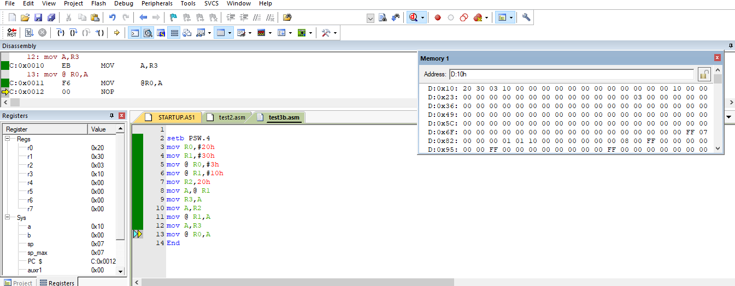

1. **Repeat the Questions 1 & 2 with same registers of Bank2 (register bank selection by using PSW)**

**Program 1**

SETB PSW.4

mov R0,#3h

mov R1,#10h

mov A,R0

XCH A,R1

mov R0,A

END

**Output 1**

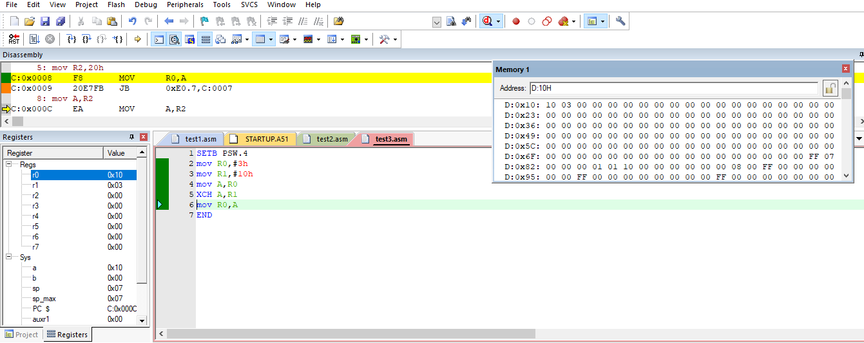

**Program 2**

setb PSW.4

mov R0,#20h

mov R1,#30h

mov @ R0,#3h

mov @ R1,#10h

mov R2,20h

mov A,@ R1

mov R3,A

mov A,R2

mov @ R1,A

mov A,R3

mov @ R0,A

End

**Output 2**

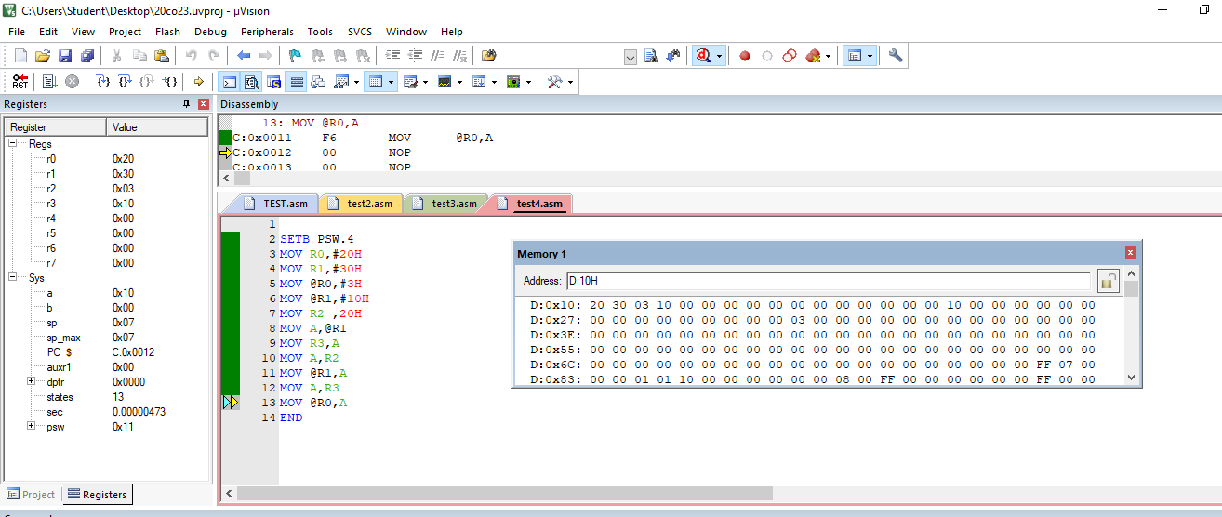

1. **Set the Internal RAM locations from address 60h to 70h with an immediate operand FFh.**

**Program**

mov R0,#60H

loop1:mov @ R0,#0FFH

inc R0

cjne R0,#71h,loop1

End

**Output**

**Before**

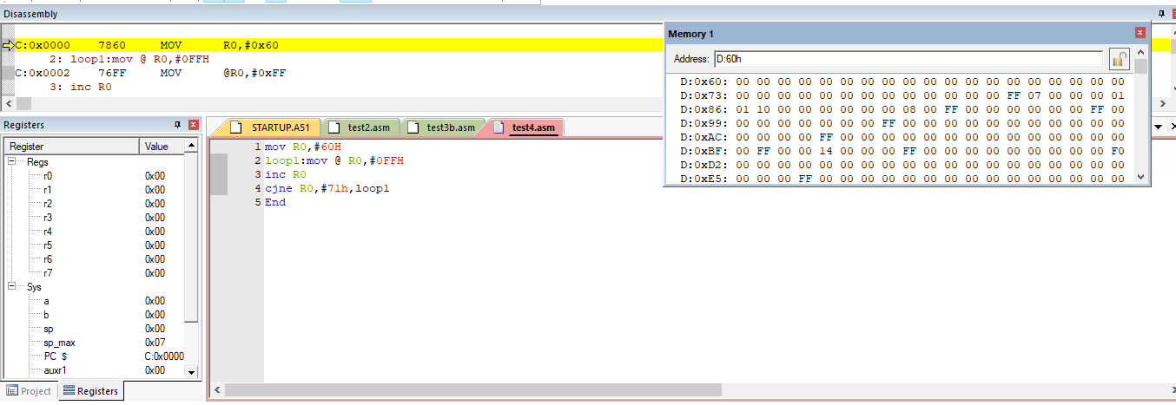

**After**

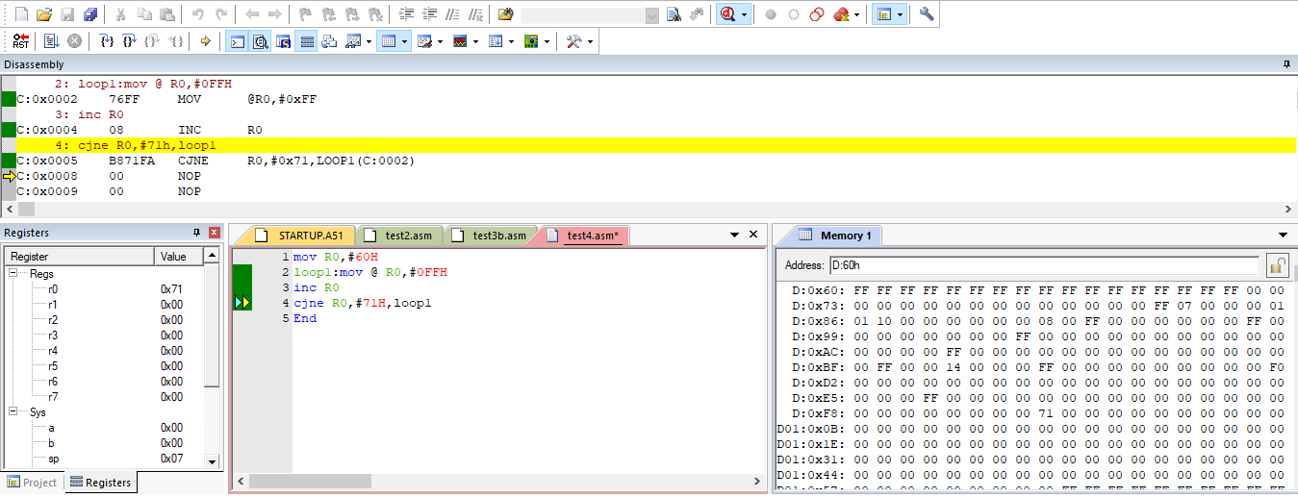

1. **Transfer 10bytes of data from Internal RAM location 50h to 70h.**

**Program**

MOV R0,#50H

MOV R1,#70H

MOV R2,#0AH

LOOP1:MOV A,@R0

MOV @R1,A

INC R0

INC R1

DJNZ R2,LOOP1

END

**Output**

**Before**

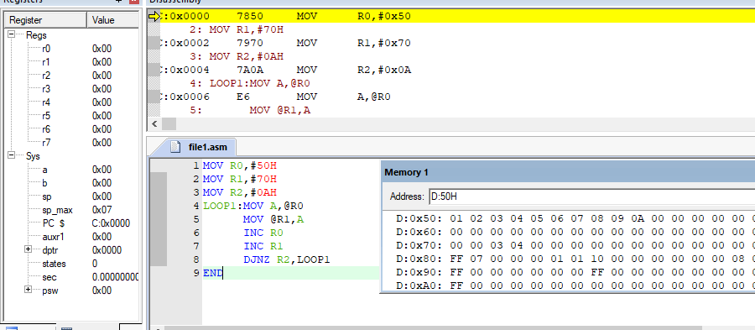

**After**

